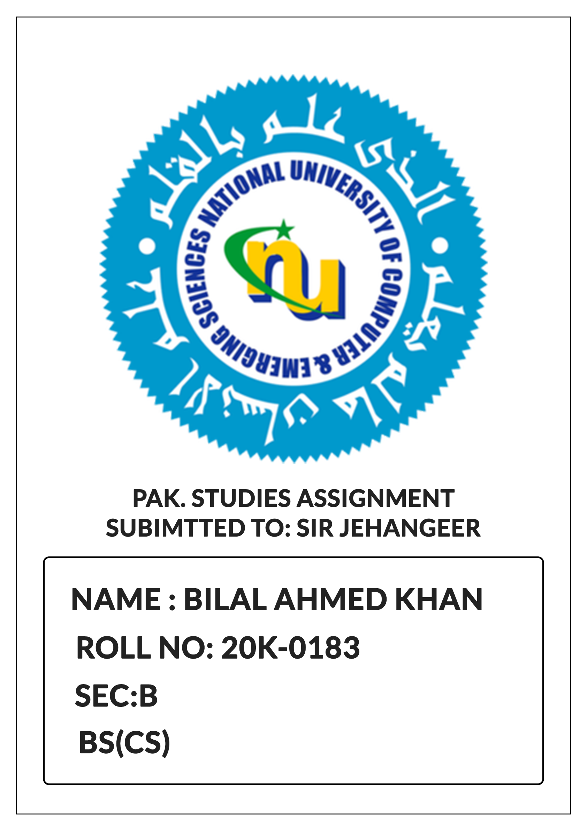

**Set 6:**

**List of articles:**

1. Republic and its territories.
2. Islam to be state religion.
3. Eliminations of exploitation.
4. Right of individuals to be dealt according to law.
5. Loyalty to the state.
6. High treason.
7. Definition of state.
8. Law against fundamental rights to be void.
9. Security of a person.
10. Safeguards as to arrest and detestition.
11. Slavery and forced labor prohibited.
12. Protection against retrospective punishment.
13. Protection against double punishment.
14. Dignity of humans.
15. Freedom of movement.
16. Freedom of assembly.
17. Freedom of association.
18. Freedom of trade and business.
19. Freedom of speech.
20. Freedom of profess religion.
21. No taxation against particular religion.
22. Safety of educational institute in sense of religion.
23. Freedom to purchase property.
24. Protection of property rights.
25. Equality of citizens.
26. Right of access to public places.
27. No Discrimination in services.
28. Preservation of language, script and culture.
29. Principles of Policy.
30. Responsibility with respect to principles of policy.
31. Islamic way of life.
32. Promotion of local government institutes.
33. Parochial and other similar prejudices be discouraged.
34. Full participation of women in national life.
35. Protection of family
36. Protection of minorities
37. Promotion of social justice and economic well-being of people
38. Promotion of social justice and eradication of social evils.
39. Participation of people in armed forces
40. Strengthening bonds with Muslim world promoting international peace

**Article 01: Republic and tis territories**

1. Pakistan shall be federal republic known as FROP
2. Territories:

Provinces 4.

ICT- Federal Capital

States and territories may be included.

1. Parliament to decide whether to include or not any territory

**Article 2: Islam to be state religion**

* + Islam state religion of Pakistan**.**
  + Objective resolution part of constitution

**Article 3: Elimination of Exploitation**

State shall ensure the elimination of all forms of exploitation and gradual fulfillment of fundamental rights.

**Article 4: Right of individuals to be death a/c to law**

Every citizen enjoys protection of law:

* + - No detrimental action to life, liberty exception of law.
    - Freedom of doing everything except what law prohibits.
    - None be compelled to od which law does not ask to do.

**Article 5: Loyalty to State**

* + Loyalty to state in basic duty of every citizen
  + Obedience to constitution

**Article 6: High Treason**

* + Anyone who abrogates, subverts, supersedes or conspires- GOHT
  + Anyone who abets
* Guilty of high treason
  + Act of HT shall not be validated by any court SC or HCS.
  + Majlis Shura by law will provide punishment of person founded of high treason.

**Article 7: Definition of State**

State means federal and provincial government and assemblies and such local or other authorities by law empowerment to impose any tar or cess.

**Article 8: Law in constituent with or in derogation of fundamental rights to be void**

**Article 9: Security of a person**

According to law no person will be deprived of life or liberty

**Article 10: Safeguards as to arrest and detention**

* + Arrested cannot be detained in custody without being informed. He has right to consult and be defended by legal petitioner.
  + Arrested be produced to near magistrate within 24 hours.
  + Right to fair trial under civil rights.

**Article 11: Slavery, forced labor are prohibited**

* + No place for slavery
  + Human trafficking and forced labor is prohibited.
  + Child under 14, cannot be engaged in factor or hazardous mine.

**Article 12: Protection against retrospective punishment**

* No law authorizes for punishment of a person.
* That was not punishable by law.

**Article 13: Protection against double punishment incrimination and self**

* No punishment more than one time for committed offence
* No force to be witnessed against himself.

**Article 14: Dignity of humans**

* Dignity of mass and privacy home be instated
* No torture for entracity evidences.

**Article 15: Freedom of Movememnt**

Without any reasonable restoration of law a person can move and reside any part of the country.

**Article 16: Freedom of assembly**

People are allowed to assemble peacefully without arms except soem law exceptions

**Article 17: Freedom of association**

* + Citizens are allowed to form associations and unions, subject to reasonable restriction imposed by law in interest of sovereignity, integrity and public interest of people.
  + Person who is not in Govt. service can be part of political party which is not against of state.
  + Every political party shall account for the source of its funds in accordance with law.

**Article 18: Freedom of trade, business and profession**

Citizens to enter in any profession or occupation subject to law or qualifiction.

* + - Prevention of trade without license
    - Regulation of trade in interest of free competition prohibited.
    - Carrying on by federal, provincial govt or corporation controlled by any such govt.

**Article 19: Freedom of Speech**

Freedom of speech subject to reasonable restriction by law.

**Right to information**

Right to acces information in all public matters subject to resonable restriction by law.

**Article 20: Freedom to profess religious and manage religious institutions**

* Right to profess, practice and propagate one’s religion
* Every religiously institute to maintain and manage its institution

**Article 21: Safeguard against taxations for purpose of any particular religion**

None can be compelled to pay tax which is be spent on the propagation and maintenance of religion other than his own.

**Action 22: Safeguard as to educatoinal institutions in respect of religion etc**

* None cn be forced in any institution for religious propagation other than his own.
* No discrimination against any community in texation
  + No community be prevented from providing religious information
  + No citizen be derived to take admission in any educational institution on the basis of race, religion or caste.

**Article 23: Freedom to purchase property**

All citizens can purchase exception of law

**Article 24: Protection of property rights**

**Article 25: Equality of citizens**

* + All citizens are equal before law
  + No discrimination on the basis of sex
  + Protection of women and children

**Article 26: No discrimination in access to public places**

* + Access to public places to all
  + Special provisions to protect women and children

**Article 27: Safeguards against discrimination in services**

Equality in services regardless of religion, caste and creed.

**Article 28: Presentation of language, script, culture etc**

Right to preserve and promote language, culture adn institutes.